Week in Review - March 15-21
Alex Shvartsman

PRO TOUR: TOKYO AND THE TOKYO MASTERS SERIES
All kinds of records were broken this weekend.

- Tsuyoshi Fujita became the first player from Asia to make Top 8 of a Pro Tour. Fujita is one of the most experienced Japanese players, having competed in a total of 13 Pro Tours (his best previous finish being 26th at the World Championships 1999 in Yokohama). Fujita is also the winner of this year's Grand Prix: Kyoto, and has three other GP Top 8 finishes in Japan and Taiwan. Fujita was not the only Japanese player to deliver on the home turf - team Panzer Hunters that qualified for the Masters Series on a last-minute appeal surprised all by upsetting several of the world's most established teams to finish 2nd, losing only to AlphaBetaUnlimited.com.
- The core of team AlphaBetaUnlimited.com - Ryan Fuller, Noah Boeken, and Chris Benafel braved the field of twenty-something Gateway teams, and defeated the team of Keller, Keller and Clegg (sounds like a law firm, doesn't it?) in the finals to qualify for the Masters. They went on to become the first players to win the Masters tournament after qualifying for it via the "meatgrinder."
- AlphaBetaUnlimited (named after their sponsor, AlphaBetaUnlimited.com online card store) did not stop there. They went on to set another record - getting a total of four players in their playtest group (Fuller, Benafel, Hager, Freneau) into the Top 8. Several others finished in the Top 32, making it the strongest performance by any team in a single Pro Tour ever.

- Ryan Fuller set yet another record - he became the first player to go undefeated through all fourteen rounds of Swiss. Although he lost in the round of Top 8 to Chris Benafel, Fuller is likely to hang on as a sole owner of such a record for a while. The only other similar finish was by Jon Finkel at Grand Prix: Boston in 1998. Having 3 byes, Finkel went 14-0 in Swiss and then won the three single elimination rounds, winning in what is still considered to be the toughest GP Top 8 ever. Still, not even Finkel managed a similar record at Pro Tour level.
- Zvi Mowshowitz won it all with a brilliant metagame deck (designed by John Ormerod). Far as I know, this is the first time members of the same gaming club (Neutral Ground) won two Pro Tours in a row.

COMING UP: GRAND PRIX GOTENBORG
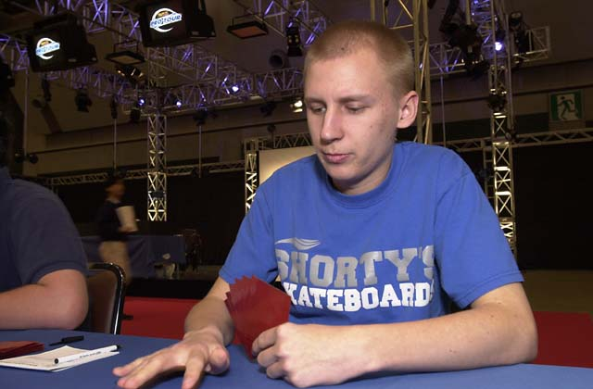
Hometown boy, Olle Rade
Grand Prix circuit returns to Sweden this weekend, with another Invasion/Planeshift Limited Grand Prix. There are only two left - Gotenborg, and GP Detroit a week later. For most players, this is the last chance to qualify for PT Barcelona, while several are using it (and other GPs) to vie for positions at the top of the Pro Tour race standing.
Having included GP Prague, Rio, and PT Tokyo, the current standings look like this:
60 Mike Pustilnik
58 Kamiel Cornelissen
52 Zvi Mowshowitz
50 Kai Budde
49 Scott Johns
45 Ryan Fuller
43 Gary Wise
42 Chris Benafel
41 Tsuyoshi Fujita
39 Mike Turian
Mikey P, Jon Finkel and Kamiel Cornelissen were perhaps the most watched players in Tokyo. Pustilnik and Finkel both failed to make Day 2, but Cornelissen finished 29th. Anyone who was still reluctant to admit him as one of the best players in the game can hardly argue with the fact now. After all, 29th place is his worst finish ever in an individual Pro Tour - how many players who competed in several PT events can claim that?
Pustilnik will be skipping GP Gotenborg. Mowshowitz, on the other hand, managed to buy a last-minute ticket. He did not plan to go originally, but now that he is in contention for the POTY race lead, he feels the need to travel. Budde will likely be there as well. Question is, will Cornelissen come? Only two points behind Pustilnik, I will be surprised if he doesn't.

MAGIC TRIVIA
Last week's question:
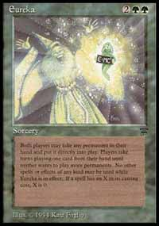
What other Legends' card makes a reference to Einstein in its artwork?
Eureka. In its artwork, the card features the E = MC2 formula, made famous by Einstein.
One of the readers also suggested that King Suleiman and Nebuchadnezzar could count as correct answers to the historical characters features on Magic cards question.
New question:
Although Zvi is best known as a deck builder, he won a Pro Tour with a deck designed by a teammate. Even the best of deck builders sometimes succeed with a deck that another player gets most of the credit for building. Here are several tournament winners. Can you figure out what players are credited with designing their decks?
Sigurd Eskeland - Rising Waters - Pro Tour: New York 1999
Bob Maher, Jr. - Oath - Pro Tour: Chicago 1999
Jon Finkel - Black Control - U.S. Nationals 2000
Casey McCarrel - Tinker - Pro Tour: New York 1998

YOUR MANA'S WORTH
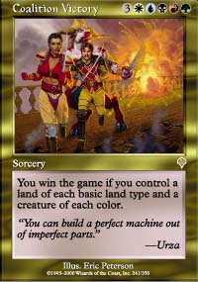
The following question was sent in by one of the readers: "Can I play a Coalition Victory and give my Quirion Dryad 4 +1/+1 counters?" Says level 3 judge Michael Feuell: "Quirion Dryad's ability triggers only once for each spell cast, so even if a player casts a multi-color spell, the Dryad will only get one +1/+1 counter."

BEST OF THE NET
11th place GP Boston finisher Bruce Cowley wrote an excellent tournament report. Cowley does not write often, but when he does it is usually worth a read.

PLAY OF THE WEEK
Reported by Nuno Silva, from Portugal:
"This was a play by Helder Coelho, one of Portugal's top players. It happened in 1999, in Grand Prix Lisbon, witch Coelho won. Coelho was playing a match against Suicide Black. He used Treachery to control a Phyrexian Negator, only to see his opponent cast another one. Eventually his opponent attacked and Helder blocked. He then took advantage of Sixth Edition rules by putting damage on the stack and then casting Rescind on his Treachery. The renegade Negator returned to his opponent's control and the helpless opponent was forced to sacrifice 10 permanents!"

BAD PLAY OF THE WEEK
Reported by Rob Monge:
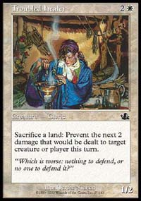
Two people are playing Mercadian Masques block Sealed. One has a Cho-Manno, Revolutionary and a Troubled Healer in play. He is however low on life, and is facing several larger creatures. The white player is tapped out. At this point, his opponent draws a Rhystic Lightning. The right play is to deal four damage to an opponent and "Armageddon" him, right? Not according to this guy. He taps three mana and casts Lightning targeting Cho-Manno Revolutionary!
This alone would not be bad enough to make the column though. However, his opponent sacrifices two lands to prevent this damage!
As always, please send good/bad plays, cool trivia questions, and other news to ashv@concentric.net

